Chapter 14, Problem 70.

A second-order active filter known as a Butterworth filter is shown in Fig. 14.95.

(a) Find the transfer function V_{o}/V_{i}.
(b) Show that it is a lowpass filter.

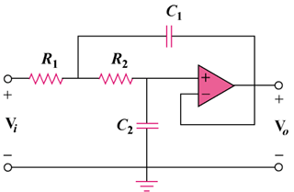

Figure 14.95
For Prob. 14.70.

